GETTING TO KNOW PLANTS

Go outside and observe all the plants around you. Do you see that some plants are small, some very big, while some are just patches of green on the soil? Some have green leaves, while some others have reddish ones. Some have huge red flowers, some have tiny blue ones, while some have none. We do see a variety of plants existing all around us —near our homes, in the school ground, on the way to the school, in the parks and gardens, isn't it? Let us get to know the different parts of any plant. This will help us

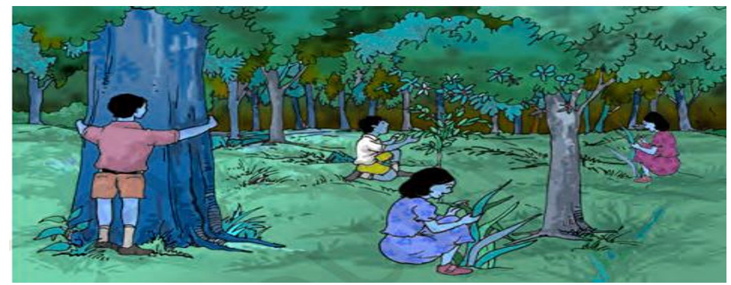

understand the differences between plants of different kinds. Can you label the stem, branch, root, leaf, flower and fruit of the plant shown in? Colour the parts of the plant.

HERBS, SHRUBS AND TREES:

Take care that the stem does not break. Hug the tall plants to see how thick their stems are! We also need to notice from where the branches grow in some plants — close to the ground or higher up on the stem. Based on these characters most plants can be classified into three categories: herbs, shrubs and trees. An example of each is shown below

|  |  |  |
| --- | --- | --- |
|  |  |  |

appears in the veins of leaves also. How do you think the colour reached there? From this activity, we see that the stem helps in upward movement of water. The water and minerals go to leaves and other plant parts attached to the stem.

Observe the leaves of some plants around you and draw them in your notebook. Are all the leaves of same size, shape and colour?

How are leaves attached to the stem? The part of leaf by which it is attached to the stem is called petiole. The broad, green part of the leaf is called lamina. Can you dentify these parts of the leaves in plants around you? Do all the leaves have etioles?

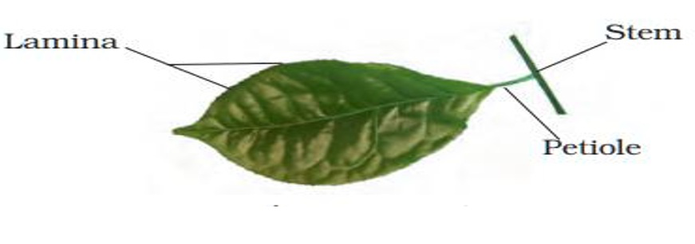

Let us get to know the leaf better by taking its impression! If you thought that leaves cannot sign, here is an activity which will make you think again.

7 Put a leaf under a white sheet of paper or a sheet In your notebook. Hold it in place as shown in. Hold your pencil tip sideways and rub it on the portion of the paper having the leaf below it. Did you get an impression with some lines in it? Are they similar to those on the leaf? These lines on the leaf are called veins. Do you see a prominent line in the middle of the leaf? This is called the midrib. The design made by veins in a leaf is called the leaf venation. If this design is net-like on both sides of midrib, the venation is reticulate. In the leaves of grass you might have seen that the veins are parallel to one another. This is parallel venation. Observe the venation in as many leaves as you can without removing them from the plant. Draw the pattern and write names of some plants having reticulate and parallel venation. Shall we now find out some of the functions of a leaf?